Style Sheet Languages

📌 Definition:
# Source: AI Source: Provided by: [Data Path: Persons Table -> ID Column: 1, Name_En Column: Motasem Essam] -> From: [ChatGPT] on [12/9/2025]
Style sheet languages are DSLs used to control the appearance and layout of content (especially web pages).

🧩 Common Examples:

🎨 CSS (Cascading Style Sheets)
# Source: AI Source: Provided by: [Data Path: Persons Table -> ID Column: 1, Name_En Column: Motasem Essam] -> From: [ChatGPT] on [12/9/2025]
- Used to style web pages
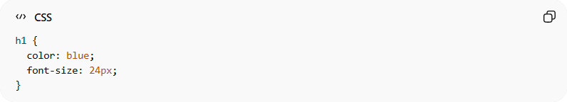
h1 {
color: blue;
font-size: 24px;
}

📄 XSL (Extensible Stylesheet Language)
# Source: AI Source: Provided by: [Data Path: Persons Table -> ID Column: 1, Name_En Column: Motasem Essam] -> From: [ChatGPT] on [12/9/2025]
- Used to style and transform XML documents
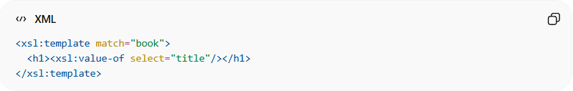
<xsl:template match="book">
<h1><xsl:value-of select="title"/></h1>
</xsl:template>

🖨️ Sass (Syntactically Awesome Style Sheets)
# Source: AI Source: Provided by: [Data Path: Persons Table -> ID Column: 1, Name_En Column: Motasem Essam] -> From: [ChatGPT] on [12/9/2025]
- Extension of CSS with more features (variables, nesting)
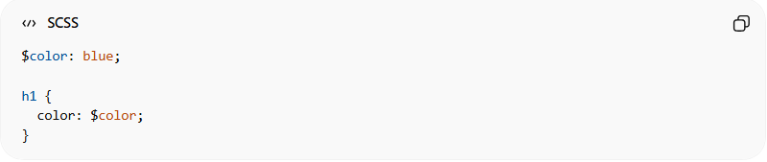
$color: blue;

h1 {
color: $color;
}

🎨 SVG Styling (Scalable Vector Graphics)
# Source: AI Source: Provided by: [Data Path: Persons Table -> ID Column: 1, Name_En Column: Motasem Essam] -> From: [ChatGPT] on [12/9/2025]
• Used to style and design vector graphics (shapes, icons)
• Styling can also be applied using CSS:
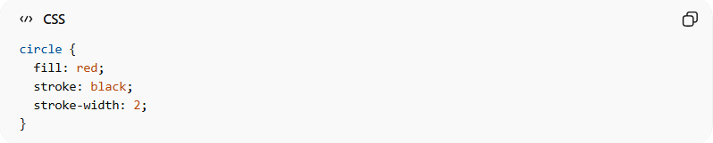
circle {
fill: red;
stroke: black;
stroke-width: 2;
}

⚙️ What they all do:
# Source: AI Source: Provided by: [Data Path: Persons Table -> ID Column: 1, Name_En Column: Motasem Essam] -> From: [ChatGPT] on [12/9/2025]
- Control design and layout 🎨
- Change colors, fonts, spacing
- Improve visual appearance

✅ Benefits of Style Sheet Languages
# Source: AI Source: Provided by: [Data Path: Persons Table -> ID Column: 1, Name_En Column: Motasem Essam] -> From: [ChatGPT] on [12/9/2025]
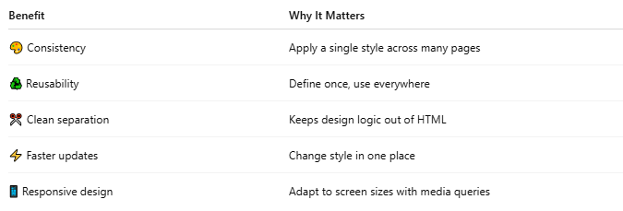

Benefit | Why It Matters
🎨 Consistency | Apply a single style across many pages
♻️ Reusability | Define once, use everywhere
✂️ Clean separation | Keeps design logic out of HTML
⚡ Faster updates | Change style in one place
📱 Responsive design | Adapt to screen sizes with media queries

🆚 Key idea:
# Source: AI Source: Provided by: [Data Path: Persons Table -> ID Column: 1, Name_En Column: Motasem Essam] -> From: [ChatGPT] on [12/9/2025]
All style sheet languages are:
- ✅ DSLs (Domain-Specific Languages)
- ❌ Not programming languages (no full logic like loops/conditions)

🎯 Summary:
# Source: AI Source: Provided by: [Data Path: Persons Table -> ID Column: 1, Name_En Column: Motasem Essam] -> From: [ChatGPT] on [12/9/2025]
Style sheet languages are DSLs designed specifically to control how content looks and is displayed.

